User Manual
The project is all about for the milk product shop management . There are main attributes are
- Shop kipper
- Orders
- Stack / Products
- Login
Login part is for Admin (Shop keeper ) .
On counter there are many staff are setting then new login and passwords are created for staff.
Username
Password
Both are required for login successful

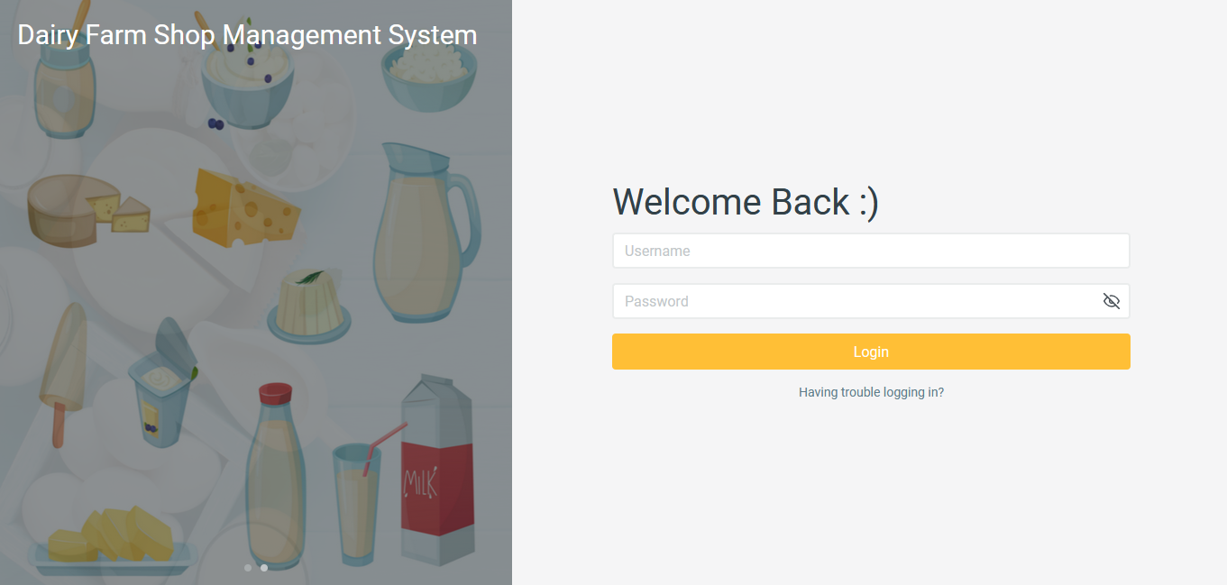

- Dashboard
Dashboard for the user after successful login . In the dashboard there are the three parts
- User
- View of stokes
- Update orders and mange stacks

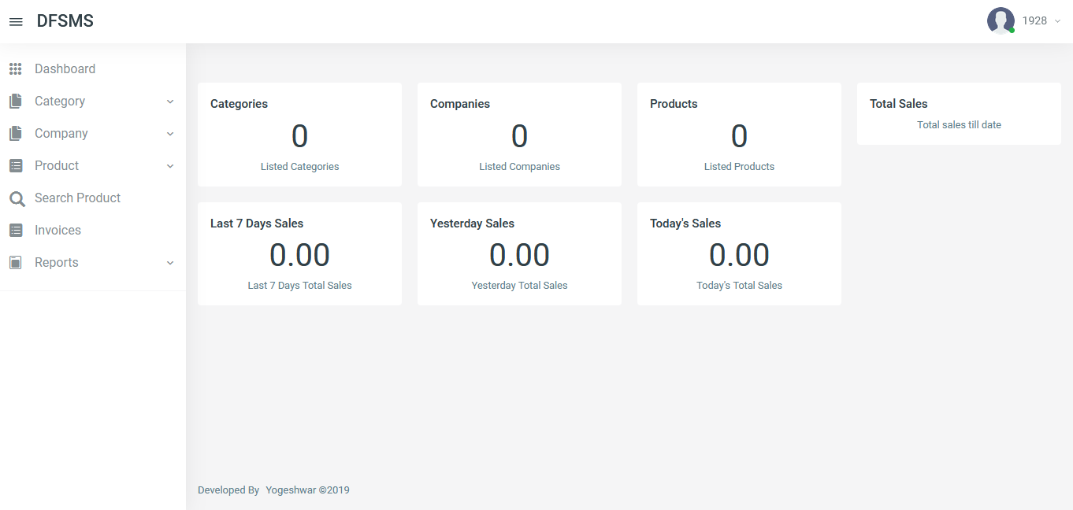

  - View the stacks
This is basically all reports of the of the shop till the system date .
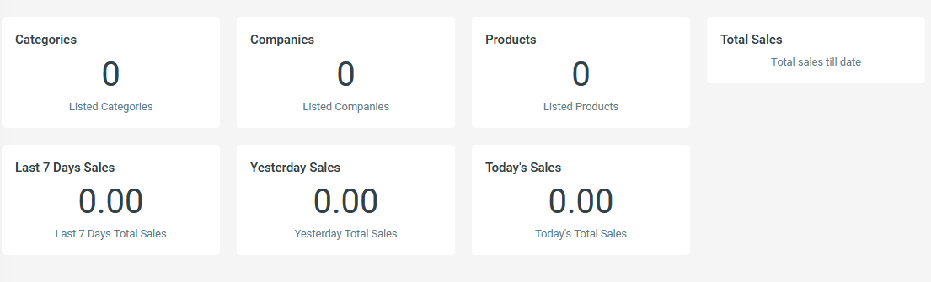
  - User Modifications
The part for user ,if user want to change the passwad or credentials
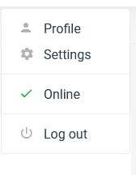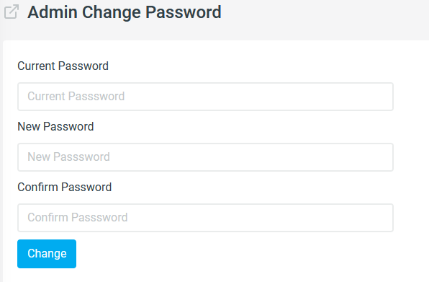
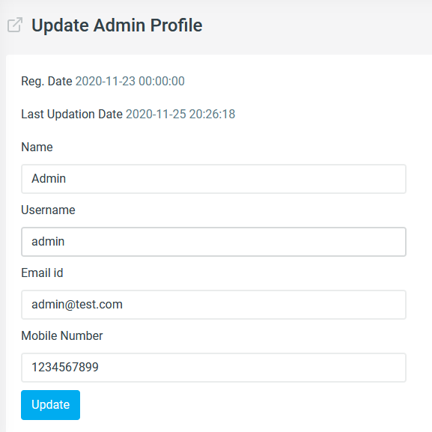

- Categoris
This are the by product of milk and milk .
  - Add
Add the different Categories in the table
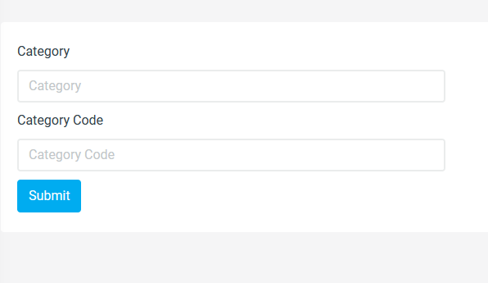

  - Manege
For modification of Categoris
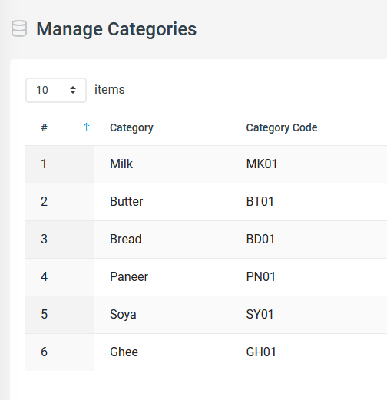

- Company
It is for the company which are the suppliers for shop
  - add
add new company
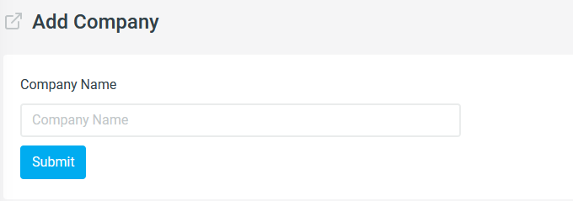
  - Manage
Manage the campany by adding the new campanys
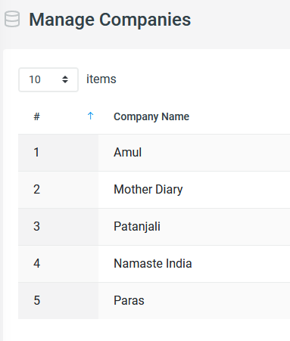

- Orders
Products which are purchased by customers this is basically for order management.
Create order
Create invoice
Add product to cart
Empty cart
Print invoice
Payment
- Reports
Sales report
Monthly report

2nd User is staff for staff :-
- Taking the order
- See the company ,categories and product
- Pay for invoice

